Burnside West Christchurch University Cricket Club

Established 1972
West Christchurch 1905
Burnside 1958

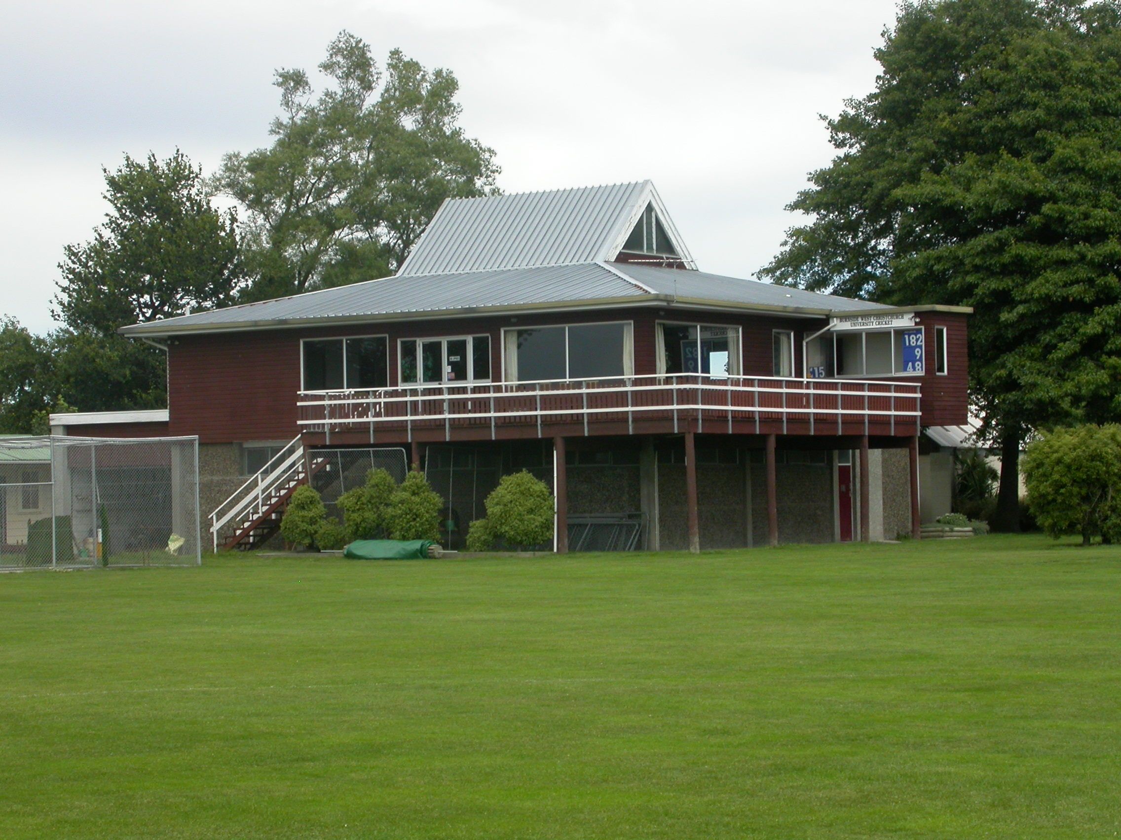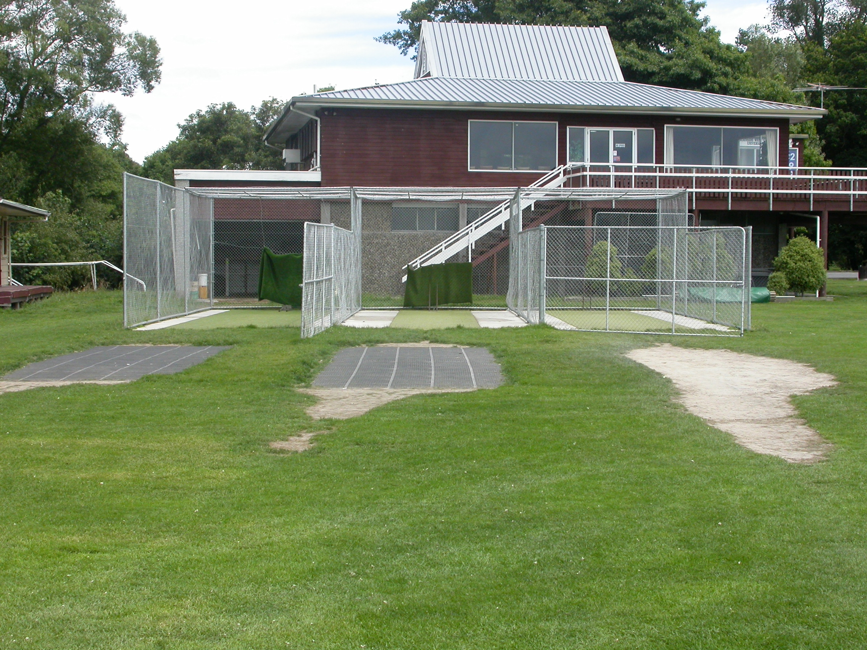

Home Ground Burnside Park
Match pitches 4 grass match pitches 1 artificial match pitch
Practice pitches 3 artificial pitches

Entries 2001-02 9 men teams 1 women team 13 junior teams
2002-03 9 men teams 1 women team 26 junior teams
2003-04 10 men teams 2 women teams 21 junior teams 2004-05 8 men teams 1 women team 23 junior teams 2005-06 9 men teams 21 junior teams

Grade wins last 6 years
Men 2000-01 Seventh grade
2003-04 Fifth grade Sixth grade
2005-06 Sixth grade

Subscriptions Adult $205
Student $175
Junior $50

Income 2004/05 Subscriptions $22,169
Gaming $24,460
Total $63,564
Expenditure Grounds $11,961
Gear $2,924
Total $61,631
Surplus $1,933
Accumulated Funds $126,372

